Food Webs and Food Chains
Task 1:
Tertiary consumer  Herbivore  Producer  Secondary consumer  Omnivore  Carnivore  Primary consumer | Usually plants. Starts off a food chain  Animals that only eat plants  An animal that eats producers  An animal that eats secondary consumers  Eats only animals  An animal that eats primary consumers  Eats both animals and plants
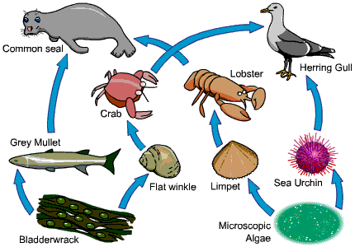
Task 2:

- Draw a food chain from this food web
________________ ________________ _________________ __________________
- Using the food web, write the name of a:
- Carnivore ______________________
- Herbivore ________________________
- Producer __________________________
- Primary Consumer _____________________
- Secondary Consumer _______________________
- Tertiary Consumer __________________________

- What do the arrows in a food chain represent? ________________________________________________

- A disease has wiped out most of the flat winkle population. Giving an explanation, what will happen to the numbers of
- Grey Mullet _____________________________________________________________________
- Crab ___________________________________________________________________________
- Lobster _________________________________________________________________

